7th February 2003

Patrick Smart
BETTA Project
Office of Gas & Electricity Markets
9 Millbank
London
SW1P 3GE

Dear Patrick

RESPONSE TO SAS CONSULTATION

We welcome the opportunity to comment on the issues set out in the joint Ofgem/DTI consultation paper on the impact of BETTA upon the Settlement Agreement for Scotland (SAS) as published in December 2002.

It is recognised that certain provisions of the SAS will need to remain in force post the implementation of GB-wide trading arrangements in order to facilitate the full reconciliation of energy traded prior to BETTA implementation. This undoubtedly raises a number of issues, however, in resolving these the principal objective should be to devise arrangements that ensure an efficient, controlled and cost-effective run-off the Scottish settlement arrangements.

With this in mind, we would like to make the following comments on the key issues set out within the consultation document. Namely:

Vehicle for SAS run-off

Given that the run-off period for the SAS could be relatively short we see little merit in incorporating the provisions required to facilitate SAS run-off as a supplement to the GB BSC. We propose the SAS continues as a stand-alone agreement and appropriately modified to facilitate the run-off period.

Administration of run-off

The role of Scottish Settlements and administrator of the SAS during the run-off period should be performed to an appropriate standard and in the most cost-efficient manner. With this in mind, and given the role will be diminishing over time, it would appear that to maintain a separate company to perform this role would not meet these objectives. Consequently, we propose that the role is transferred to GB BSCCo. However, the transfer costs should be investigated in order to ensure that these would not be more than the costs of continuing with the current arrangements. Furthermore, in the event that the role is transferred to GB BSCCo it is essential that the costs of performing this role are separately identified and recovered only from Scottish Trading parties under the existing SAS cost recovery provisions (see below).

Extent of reconciliation under SAS run-off

From a cost perspective, it is clearly sensible to explore any opportunities to curtail the SAS run-off period. It has been suggested that savings of approximately £1M could be achieved by reducing the reconciliation period to eight months (R3) from the current 14 months. Given that the level of actual data in the system at R3 is reasonably high (particularly in the HH market) reducing the reconciliation period and thereby curtailing the run-off period would appear to be appropriate. However, implementing this proposal may require changes to the Central Allocation System (CAS) and consequently incur some implementation costs. Therefore, the real net cost benefits of moving to R3 should be established before a final decision is made.

Disputes under SAS run-off

It is essential that the SAS run-off arrangements provide for an explicit end date to the run-off period. To continue with the existing SAS dispute provisions, whereby no explicit time-limit is imposed on raising disputes, is clearly not a valid option. Any proposal for an explicit dispute initiation window needs to take in to the account the risks this would place on SAS parties. However, given that there have been only four disputes raised under the SAS to date the benefits of an introducing a dispute initiation window of around two to three months (post final reconciliation) would appear to outweigh any potential downside risks.

Cost recovery

The over-riding principle in respect of cost recovery should be that the outstanding (Scottish) 98 costs and the run-off operational costs in relation to the SAS continue to be recovered only from those parties who currently pay costs under the SAS. Given that the England & Wales 1998 costs will have been completely recovered from E&W parties by March 03 and that the ongoing operational costs of the SAS post BETTA are being incurred for the benefit of Scottish parties only to recover these costs on any other basis would be entirely inappropriate. Consequently, it is essential that these costs are ringfenced from all other costs post BETTA implementation.

With respect to the appropriate basis for cost recovery, we propose recovery under the existing SAS provisions on the basis of pre-BETTA traded volumes over a pre-determined period. It would appear that any alternative, such as recovery on the basis of post BETTA traded volumes, would incur significant system costs resulting from the need for the GB BSCCo's systems and processes to separately identify trades in relation to sites in Scotland only.

Termination of the SAS

It would seem entirely appropriate for the SAS run-off arrangements to explicitly provide for the termination of the SAS at the end of the run-off period. Consequently, the relevant SAS licence conditions should be amended to reflect this requirement and these conditions should ultimately be removed from all licences following the termination of SAS.

If you would like to discuss any of the points raised, please do not hesitate to contact me.

Your sincerely

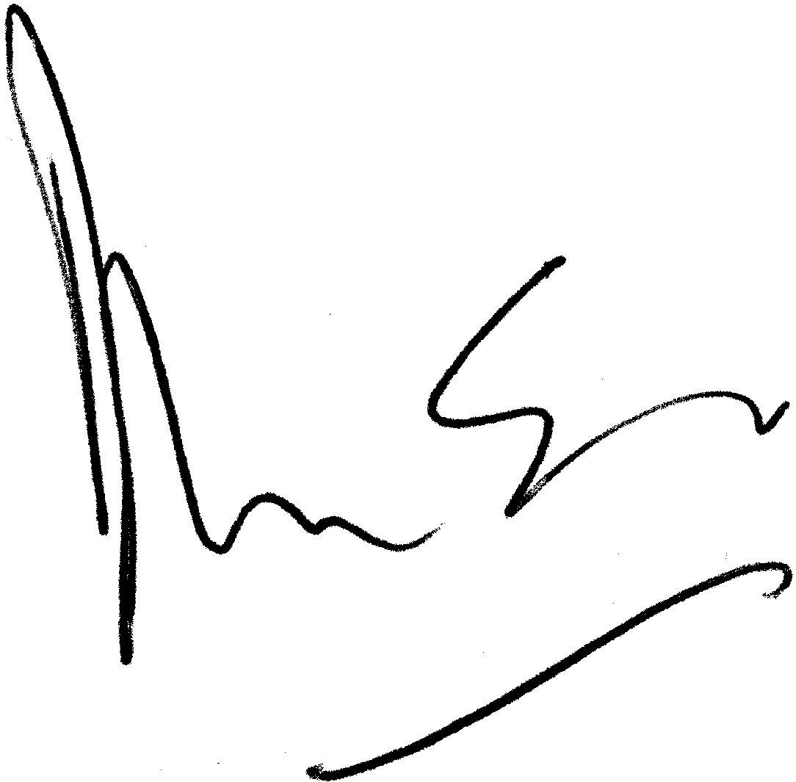

David Love
Head of Regulation

Direct Line: 01452 653325
Fax: 01452 653246
E:Mail: david.love@british-energy.com

