 |  |  | Regulation |  | The National Grid Company plc  National Grid House  Kirby Corner Road  Coventry  CV4 8JY  Tel No: 02476 423943  Fax No: 02476 423945
Date: | 15 August 2002
Lisa Vango
Ofgem
9 Milbank
London SW1P 3GE
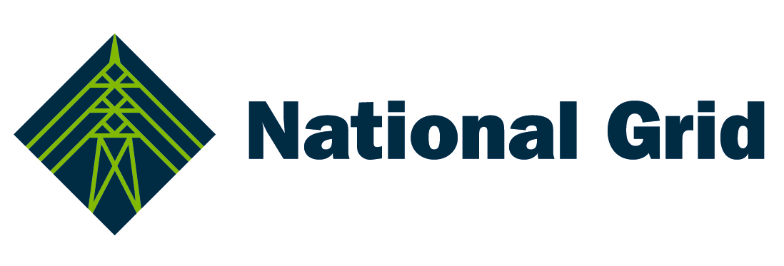

Dear Lisa

Ofgem's initial proposals on regulatory issues arising from the merger of National Grid Group plc and Lattice Group plc to create National Grid Transco plc

In its initial proposals for regulating National Grid Transco, Ofgem notes that other Ofgem consultation processes, notably those covering separate price controls for LDZs and separation of LNG facilities from Transco, will be taken forward independently of the process for regulating the merged group. However, it raises the following issues specifically in relation to the merger:

- increased scope for information sharing and scope for National Grid Transco (NGT) to take unfair advantage through operation of both networks;
- the conflict between Lattice’s generation interests and the prohibition in NGC’s licence on NGC (or any affiliated or related undertaking) procuring electricity for sale to third parties, other than in its role of balancing the transmission system;
- the need to ensure that Transco cannot access information held by EnMO about prices and volumes traded by other market participants;
- the adequacy of the financial ring fence conditions in NGC’s and Transco’s licences in the wake of the merger;
- whether new licence conditions are needed to maintain NGC’s ‘managerial focus’ on the GB licensed businesses;
- the potential re-opening of the NGC and Transco price controls to pass the efficiency benefits of the merger more quickly to customers; and
- whether the timing of the next main price reviews for NGC and Transco should be aligned.

Our response to Ofgem’s proposals in each of these areas should be considered as a joint response from National Grid Company and Transco.

Increased potential for information sharing and the scope for NGT to take advantage through the operation of both networks

Leaving aside the issue of EnMO (covered below), Ofgem does not see the need for licence changes in respect of access to, and use of, information. However, Ofgem will consider the operation of, and interaction between, the respective System Operator (SO) price controls to ensure that there are no perverse incentives.

We agree with Ofgem’s analysis of this issue.

Conflict between Lattice’s generation interests and the prohibition in NGC’s licence on NGC (or any affiliated or related undertaking) procuring electricity for sale to third parties, other than in its role of balancing the transmission system

Ofgem considers that vertical separation is important in promoting confidence in the wholesale gas and electricity markets. It considers that it is particularly important that none of NGC, Transco nor any of its affiliated or related undertakings should be allowed to be involved in the purchase or sale of gas or electricity, except with the consent of Ofgem or as permitted by their respective licences for balancing purposes. On this basis, Ofgem proposes a number of licence modifications for both NGC and Transco which would have the effect of permitting Lattice’s existing (and very small) generation interests to continue to operate within the merged group, but only for specified periods of time.

We agree with Ofgem on the importance of vertical separation in wholesale gas and electricity markets and we agree with the principle of time-limited consents for Lattice’s existing generation.

Need to ensure that Transco cannot access EnMO information about prices and volumes traded by other market participants

Ofgem notes that the operation of a trading platform (like EnMO) is not a breach of either NGC’s or Transco’s licence. It also notes that the parties have a vested interest in preventing confidential information being accessed by Transco, since failure to do so would reduce the commercial viability of EnMO and may make it more expensive for Transco, as SO, to balance its network.

However, it is Ofgem’s view that the merger may give rise to concerns that Transco (which trades frequently through EnMO) could access information about the prices and volumes traded by other market participants. Accordingly, Ofgem proposes a new licence condition (for both NGC and Transco) which would have the effect of putting an absolute obligation on the two licensees to prevent either licensee receiving confidential information from EnMO.

We agree that we have a vested interest in preventing confidential EnMO information being accessed by Transco. We also think that licence modifications to oblige the licensees to take appropriate action to prevent breach of confidentiality would be an effective way of providing additional assurance to market participants about the confidentiality of information held by EnMO. However, we think that the proposed strict liability is inappropriate, given both the inability of the ultimate holding company to ensure the non-disclosure of any EnMO confidential information to the licensee (from any source) and the licence breach consequences which could arise from any breach of the ultimate holding company undertaking. Accordingly, we believe that that the licence modifications should be in the form of either:

- an obligation on the licensee to procure from the ultimate holding company an undertaking that appropriate procedures that have the purpose of ensuring that EnMO confidential information is not disclosed to the licensee are put in place; or
- an obligation on the licensee to procure from the ultimate holding company an undertaking that it will use reasonable endeavours to ensure the non-disclosure of EnMO confidential information to the licensee either from the ultimate holding company or any company within the ultimate holding company’s group.

Adequacy of the financial ring fence conditions in the context of the merger

Both NGC and Transco have conditions (the so-called ‘financial ring fencing’ conditions) in their respective licences to protect the financial integrity of the licensees. It is Ofgem’s view that these conditions should, in general, be adequate for their purpose in the context of the merged group. Proposed modifications are partly to bring the two licences into line with each other and, in certain respects, to bring both licences into line with those of the electricity distribution licensees.

We are content with the licence modifications proposed by Ofgem.

Managerial focus

In its May 2002 consultation, Ofgem sought views on whether any further overseas acquisitions by the merged group might raise concerns over the extent to which managerial resources could be diverted away from the regulated businesses to other areas of the group, in particular to the US business. However, Ofgem also recognised the importance of the GB regulated businesses to NGT, both in terms of the revenue that they generate and in terms of reputation. Against the background of these commercial pressures, Ofgem considers that the existing regulatory regime is sufficient to ensure appropriate service delivery by the licensees.

We agree with Ofgem’s analysis of this issue.

Early re-opening of existing price controls

Ofgem notes that several respondents to the May consultation paper suggested that the Transmission Owner (TO) price controls for both NGC and Transco should be reopened immediately to ensure that efficiency savings from the merger are passed back to customers. Ofgem rejects this suggestion on the basis that efficiency savings that result from the merger will be considered and passed back to customers at the time of the next periodic review, along with general efficiency savings. As in its recent document on mergers between electricity distribution companies, Ofgem’s position is that merger savings should not be treated differently from efficiency savings from any other source.

We agree that merger savings should be treated in the same way as efficiency savings in general, i.e. that they are treated as part of the normal periodic review process. We also note that, independent of the NGT merger, Ofgem is reviewing how RPI-X controls operate and, as part of this review, the impact of the timing of efficiency savings on how they are shared between shareholders and customers. As part of this review, we would hope that Ofgem will propose a mechanism which will correct the relatively small incentive on energy network companies to make efficiency savings late in a price control period.

Realignment of the timing of the next TO price reviews

Ofgem considers that there may be merit in aligning the timing of the next NGC and Transco TO periodic reviews and seeks further views on this.

We agree that there would be merit in aligning the timing of the next NGC and Transco TO price reviews, not least because of the reduced costs of undertaking the review which would result for both NGT and Ofgem and, therefore and ultimately, for customers.

Yours sincerely

Tim Tutton
Director of Regulation

