28th August 2002

Lisa Vango
Strategy and Corporate Transactions Manager
Ofgem
9 Millbank
London
SW1P 3GE

Dear Lisa

REGULATORY ISSUES ARISING FROM THE MERGER OF NATIONAL GRID GROUP plc AND LATTICE GROUP plc TO CREATE NATIONAL GRID TRANSCO plc – INITIAL PROPOSALS JULY 2002

Thank you for the opportunity to comment on the issues raised in the above consultation paper. In summary we do not believe that Ofgem’s initial proposals have properly taken account of the legitimate concerns raised by British Energy and others in response to the May consultation and that a number of these remain valid.

Key Points:

- The wider issue of access to market information remains a concern and should be addressed before the merger proceeds to remove opportunities for the merged Group to distort competition e.g. via exclusive access to live system information. Proposals to further consider this issue under NGC’s new SO incentive scheme do not go far enough.

- We welcome the proposals for vertical separation of the merged group set out in the Ofgem paper. This separation should be extended to include those areas of the respective System Operator activities which have access to market sensitive information.

- It is disappointing that Ofgem is not taking the opportunity of the merger to re-open the TO price controls. A re-opening of the relevant price controls is the most appropriate way of ensuring that customers directly benefit from the merger at the earliest opportunity.

General Comments:
In response to the specific issues on which views are sought, we make the following comments:

Access to Information and Vertical Separation
We are disappointed with Ofgem’s proposals in this area given that almost all respondents raised concerns regarding the increased access to information that NGC Transco will have now that the merger has been cleared. Ofgem place great reliance on procurement and use of Balancing Services statements required via special conditions in NGC’s licence and proposals for Transco’s licence plus the use of operational and balancing services fora as means of minimising any distortions. In reality these documents are general in nature and lacking in specifics which makes the policing of such requirements very difficult and impractical. An obligation to increase “vertical” separation between operational activities of the respective System Operators and the remainder of the group would satisfy many of the concerns raised without creating excessive bureaucracy or inefficiencies.

We note the fact that Ofgem will be considering the operation of and interaction between NGC and Transco’s respective SO price controls and incentives as part of its ongoing work programme. However, this will not meet the widely expressed concerns as effectively as the increase in vertical separation advocated above.

Synchronisation of regulatory Work Programmes
We are disappointed that Ofgem is not taking the opportunity of the merger to re-open the TO price controls. We remain of the view that a re-opening of the relevant price controls is the most effective and appropriate way of ensuring that customers directly benefit from the merger at the earliest opportunity. Our reasons for taking this view were set out in our response to the May consultation and are summarised here for completeness:

- NGC expects the merger to generate financial benefits of at least £100M by the end of the first full financial year (with the combining of the support services provided to the UK regulated network businesses being a contributing factor).
- Furthermore, NGC expect to generate further savings from combining the operations of the two UK transmission businesses. Consequently, it is evident that substantial costs savings will be made following the merger. We consider it appropriate that customers of the network businesses benefit from these efficiency savings. As the price controls of these monopoly businesses have only recently been set and are due to run for another 4/5 years a re-opening of the controls will be necessary if customers are to directly benefit from the proposed merger.
- It would be unacceptable to defer the passing on of these benefits to the next price control review.

Impact on BETTA
We mentioned in our May response that NGC as the Transmission Licence holder and most significantly the current electricity system operator in England & Wales would be playing a significant role in the development of BETTA. We also stated that in our view Ofgem should seek confirmation from NGC that the merger would not hinder in any way the timely development of the BETTA arrangements. Has such confirmation been sought and if so what was the response?

If you wish to discuss these issues further please do not hesitate to contact me.

Yours sincerely

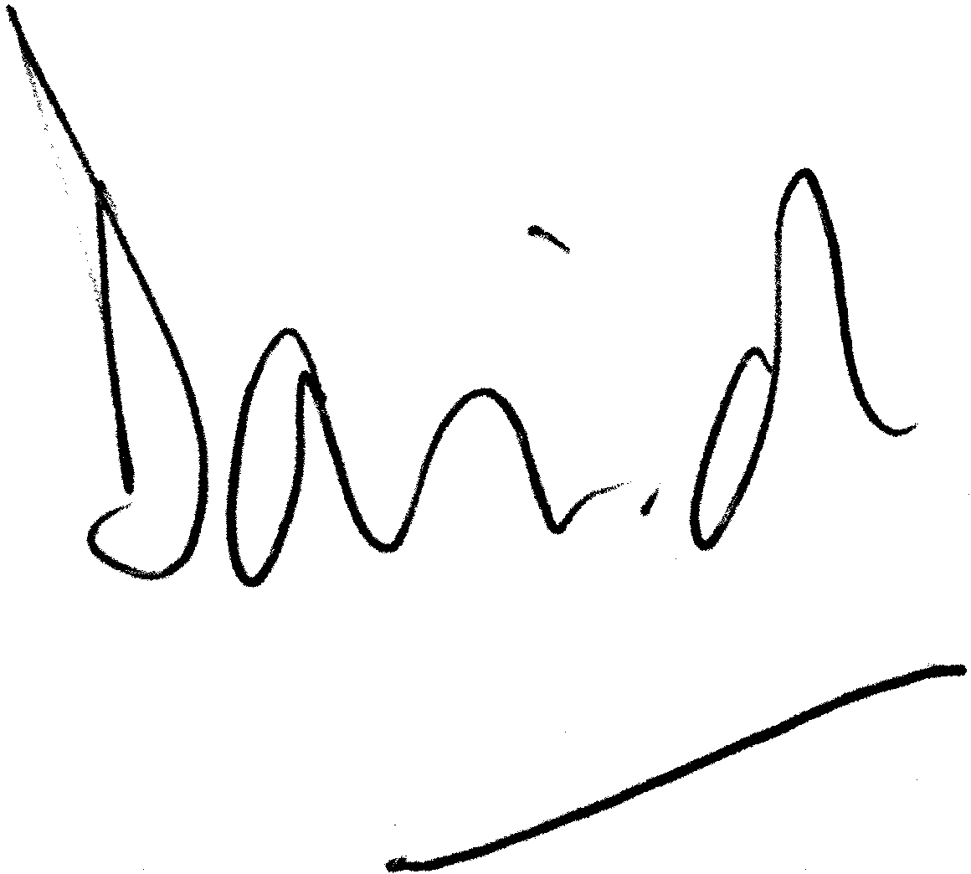

David Love
Head of Regulation

Direct Line: 01452 653325
Fax: 01452 653246
E-Mail: david.love@british-energy.com

