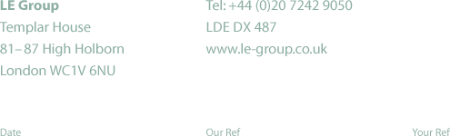

29 May 2002

Callum McCarthy
Chief Executive
Ofgem
9 Millbank
London
SW1P 3GE

Dear Callum

National Grid Transco

Thank you for providing the opportunity to comment on the proposed merger of NGC and Lattice.

We broadly welcome the merger as a positive and natural development. It should make it easier to address any security of supply issues arising from the increased reliance of electricity production on gas and changes in the sources of gas. At the same time, further consideration will need to be given to the implications for markets, and their participants, of bringing together in one organisation the two system operator (SO) roles.

We agree that there are no competition issues arising from the merger in respect of asset ownership and development. We also believe that the current regulatory requirements for the financial ring-fencing of the network businesses are adequate protection against financial instability arising from other activities of the new group.

We understand that Ofgem intends in due course to consult fully on the other regulatory issues arising from the merger. We would welcome this. We own gas fired generation and therefore our financial position in the electricity balancing market is critically dependent on the performance of Transco in maintaining the delivery of gas. Ofgem will need to consider what additional regulatory oversight may be required so that the position of such generation is safeguarded.

In respect of the operation of SO incentive schemes, we agree that the sharing of information could have a beneficial effect and, in particular, may enhance the security of supply. However, given that the merged organisation will aim naturally to optimise its benefit over the combination of the two schemes, it seems possible that National Grid Transco’s behaviour would become less predictable and transparent. There could, for example, be distortions in locational signals, which could in turn affect the development and operation of different generation in different parts of the country. Clearly, information about power station bids could indicate changes in gas availability, thus giving Transco commercial advantage.

The position that National Grid Transco will hold in the UK energy market will be one of considerable power and responsibility, which I am sure, with the appropriate incentives, they will be capable of exercising for the benefit of those trying most efficiently to meet the needs of end customers. It is important therefore that those incentives, and how they might interact, are fully reviewed by Ofgem, in consultation with market participants.

I hope you will find these comments helpful.

Yours sincerely

Vincent de Rivaz
Chief Executive

cc: Lisa Vango, Strategy and Corporate Transactions Manager

