Ref: | TT/ljc
 |  |  | Regulation |  | The National Grid Company plc  National Grid House  Kirby Corner Road  Coventry  CV4 8JY  Tel No: 02476 423943  Fax No: 02476 423945
Date: | 27 May 2002
Lisa Vango
Strategy and Corporate Transactions Manager
Ofgem
9 Millbank
London SW1P 3GE
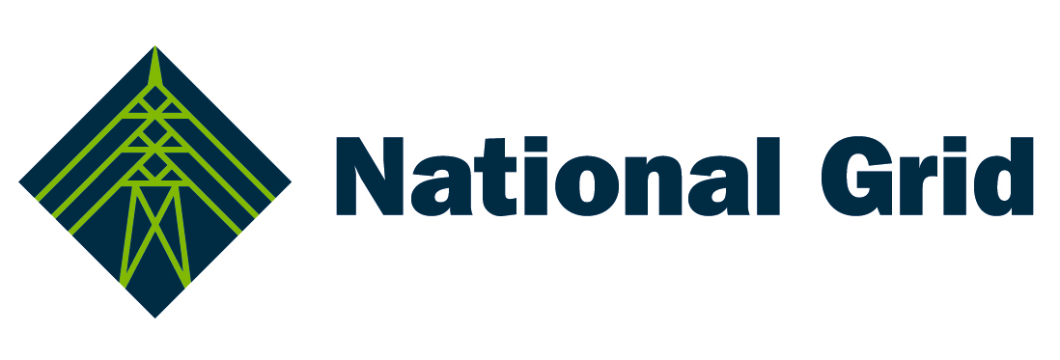
Dear Lisa

Ofgem’s consultation paper on the proposed merger of National Grid Group plc and Lattice Group plc to create National Grid Transco plc

In the consultation paper, Ofgem asks, in particular, whether:

- the proposed transaction raises any competition concerns with regard to an overlap of activity within the gas and electricity sectors, in particular between the two network businesses as system operators;

- the increased potential for information sharing between the two network businesses might operate to the disadvantage of other parties and to what extent, if any, steps may be required to address this;

- there are any activities undertaken by either National Grid or Lattice which may, if included within the combined group, raise competition concerns and to what extent, if any, steps may be required to address this;

- the proposed transaction raises any issues in relation to the security of gas and electricity supplies and more generally the efficient and effective operation of both markets and to what extent, if any, steps may be needed to address both concerns;

- in the light of the proposed merger, there is anything that suggests that the timing or content of Ofgem’s work programmes on transmission operator price controls/quality of supply issues, system operator price controls (including incentives) and LNG should be altered; and whether

- there are any other regulatory issues that may arise as a result of the proposed transaction.

We have discussed our response below with Lattice and this letter can be regarded as a joint response from us both.

Overlap of core regulated activities within the gas and electricity sectors

We agree with Ofgem that “in relation to the ownership and development of electricity and gas transmission and gas distribution networks ….NGC and Transco are not in direct competition with each other given that the networks deliver substantially different products”.

In relation to the operation of the electricity and gas transmission systems, Ofgem notes that National Grid Company and Transco, as the system operators for electricity and gas respectively, perform similar roles. However, the two system operators are responsible for moving different commodities over different networks to different timescales. In any event, both network ownership and system operation roles for both National Grid Company and Transco are subject to rigorous ex ante regulation to ensure that customer interests are protected. The merger does not, in any way, compromise that protection.

Against this background, and subject to what is said below about access to information and about EnMO, we do not believe that any competition concerns arise from overlap between the core regulated activities of the two companies.

Access to information

Ofgem asks whether an increased potential for information sharing between the two network businesses would give the merged group an unfair advantage over others. In this context, it is worth noting that:

- Use of information by each party in its system operator capacity is regulated by Ofgem under the licences, the Network Code and the Balancing and Settlement Code. As a result of these, the parties are required not to take unfair advantage of their position and must disclose relevant information. National Grid Company’s licence restricts the activities that it can undertake using the information: it is not permitted to engage in speculative trades, only those required for efficient and economic system operation. Ofgem is currently consulting on a similar condition for Transco’s licence.

- The information that each system operator receives during the time periods in which other market participants could still act on that information is made available to the market as a whole where required under obligations in the licences and under the Network Code and Balancing and Settlement Code.

- In the case of the electricity market, some information is received only in operational timescales and the National Grid system operator is therefore the only body in a position to use that information. This asymmetry already exists. For example, National Grid Company is able to undertake arbitrage bid/offer acceptances under the Balancing Mechanism in order to balance the network more efficiently.

- Both National Grid Company and Transco hold regular operational fora at which market participants can question the respective system operators about their actions.

- Both parties are also required to report annually on their balancing actions and each party’s operations in the balancing market are subject to external audit.

- Further controls exist through the financial services regulatory frameworks. The Code of Market Conduct (to which all relevant market participants are subject, regardless of exempt status under the Financial Services and Markets Act 2000) imposes financial penalties for market abuse.

- To the extent that, as purchasers and sellers, National Grid Company and Transco are better informed than before, their decisions are expected to be more efficient. Given the incentive schemes to which both are subject, this can be expected to lead to lower costs being incurred in balancing the respective systems than would otherwise be the case, with savings passing through to the benefit of customers.

On the basis of the above, we do not see that increased access to information within the merged group would give an unfair advantage to either of the system operators.

Other activities

Ofgem asks whether there are other activities in which National Grid and Lattice engage within the gas and electricity industries which, if included in the combined group, raise competition concerns and to what extent, if any, steps may be required to address this.

Each activity relevant to these questions is discussed in turn:

- Electricity interconnectors. Both of National Grid Company’s existing interconnectors (to Scotland and to France) are covered by its licence and regulated both with respect to the total amounts which can be charged and with respect to non-discriminatory access. In addition, National Grid is developing proposals for interconnectors to Norway, the Netherlands and Ireland. These may be subject to regulation by requiring third party access to be provided, although the revenues may not be subject to price controls.

- EnMO. We recognise the concern that Transco could benefit from access to confidential information in EnMo with regard to the on-the-day commodity market (OCM) in gas. However, it should be noted that: as described above, both Transco and National Grid are already obliged to avoid discrimination and are constrained in how they may disclose and use information; if EnMO’s credibility to market participants is compromised, traders will switch to other short term markets, to EnMO’s commercial disadvantage; and, if EnMO lost credibility, illiquidity in the OCM would disadvantage Transco, in its role as system operator. Having said all of this, the role of EnMO could be resolved through normal regulatory means if Ofgem considered there to be a need to strengthen the existing controls.

- Generation. Lattice Energy Services owns and operates a number of small CHP plants. We recognise that National Grid Company’s Transmission Licence currently imposes a prohibition on the holding of any interests in generation, subject to one small and specified exception. This prohibition currently extends to affiliates and related undertakings and, accordingly, we accept that an appropriate regulatory solution will be required if any group generation interests are to be allowed to continue. Transco also has a number of initiatives in which electricity would be produced as a bi-product of the transportation process. If the economic/environmental case for these initiatives proved compelling, and given that it would be difficult for anyone other than Transco to undertake these projects, there would be a strong argument for allowing Transco itself to continue with these activities, subject to appropriate regulatory oversight.

Security of gas and electricity supplies

Ofgem recognises that the merger may bring benefits to security of supply through operational synergies between the gas and electricity network businesses, but raises two potential concerns, specifically that:

- any financial failure of the parent company would impact on the operation of both the gas and electricity networks; and

- the merged group’s planned expansion outside Great Britain would divert managerial resource away from the core regulated businesses.

We believe that such concerns are misplaced for at least the following reasons:

- After the merger, the revenues generated by National Grid Company and Transco are likely to represent a significant proportion of the merged firm’s revenues and profits. In addition, the UK network businesses will remain key to the reputation of the merged group and, therefore, a significant influence on its ability to compete in other markets. On both counts, it would make no sense for the merged firm to neglect the effective and efficient management of the core regulated businesses.

- Regulation of network businesses in Great Britain has become increasingly focused on the performance of networks. This focus takes the form of both financial incentives (through both the respective System Operator price controls and the price control on Transco’s LDZs) and wider scrutiny of asset management performance.

- The existing licences of both National Grid Company and Transco contain a number of ‘ring fencing’ conditions which have been specifically designed to ensure both that sufficient financial and managerial resources are available to the regulated businesses and that these businesses are held harmless against the financial performance of other parts of their respective groups.

Impact on Ofgem’s work programme

Ofgem asks what impact the merger might have on either the phasing or the content of its regulatory work programme and specifically as this programme relates to:

- the setting of transmission operator price controls/quality of supply issues;

- the setting of system operator price controls, including system operator incentives; and

- LNG.

Transmission operator price controls/quality of supply issues

Ofgem is currently reviewing how TO price controls should work in both the gas and electricity sectors. This is an important work programme and there is scope for removing or, at least, mitigating some of the distortions of incentives embedded in the current controls. Not the least of these distortions is the relatively weak incentive to improve operating efficiency in the later stages of a price control period.

However, it is not obvious that the merger will impact on the way in which these price controls do, or might, operate. In particular, and as acknowledged by Ofgem, the merger between National Grid and Lattice will entail no loss of comparators for use in setting price controls.

The most obvious potential impact of the merger on the operation of the TO price controls would be on the timing of the reviews of the respective controls. The current National Grid Company TO price control runs through to 31 March 2006, whereas the equivalent Transco control runs through to 31 March 2007.

There would be clear advantages in conducting the next reviews of the two TO controls at the same time, especially in terms of resource costs (for Ofgem, the licensees and third parties) and in terms of effectiveness in dealing with the costs of what may become shared services across the merged group. This synchronisation could be achieved in a variety of ways but one constraint on any changes to the timing of reviews should be avoidance of shortening the duration of either of the current TO controls. This is not least because:

- particularly under the current form of the controls, shortening either of the controls would reduce incentives to improve efficiency; and

- as Ofgem has suggested in its recent paper on mergers between distribution companies, merger efficiencies will be treated at future price reviews in just the same way as efficiencies from other sources – and other ways of achieving efficiencies would not be regarded as reasons for shortening the duration of a price control.

System operator price controls

The part of Transco’s SO price control which covers ‘internal’ system operator costs is due to run until 31 March 2007. Arguments for not shortening the duration of this control are the same as those which apply to the TO control.

Beyond that, and independent of the merger, Ofgem has indicated its desire to introduce a revised incentive scheme for National Grid Company consistent (where appropriate) with developments in relation to Transco’s proposed SO incentive scheme. Discussions on this are under way.

LNG

There is no obvious reason why the merger should affect either the timing or the substance of plans for changing the regulation of Transco’s LNG activities.

Other regulatory or competition issues

We can see no other regulatory or competition issues and we look forward to discussing with Ofgem any issues raised by third parties.

Yours sincerely

Tim Tutton
Director of Regulation

