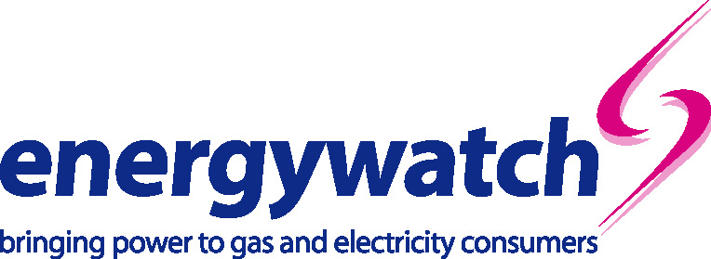

29 May 2002

Lisa Vango
Strategy and Corporate Transactions Manager
Ofgem
9 Millbank
LONDON
SW1P 3GE

Dear Lisa,

Proposed merger of National Grid Group plc and Lattice Group plc to create National Grid Transco plc
Thank you for the opportunity to respond to the above consultation paper. This letter sets out energywatch’s comments on the proposed merger.

Security of supply
The consultation document suggests that the merger may bring benefits to customers in terms of increased system security and performance. energywatch notes that one of the incentives behind the merger is the potential to expand in the United States. As both the gas and electricity networks will be under one management, we need to be confident that the new company will be committed, first and foremost, to delivering higher quality standards of service and greater value for money for consumers in Great Britain. The new company should continue to focus on asset management and investment in Great Britain to ensure that security of supply is not affected.

energywatch seeks assurances that consumers in Great Britain will not be detrimentally affected by increasing attention being given to overseas interests.

Benefits
It is expected that the merger will create £100 million annual efficiency savings. energywatch seeks confirmation of where and how the immediate and longer-term savings will be realised.

energywatch considers it is vital that the savings are passed on to customers in a timely manner. We note that Ofgem may need to consider whether the current price control decisions need to be revisited to see that consumers benefit from cheaper prices when shareholders benefit from greater dividends.

Role of comparators
We note that Ofgem recently decided that customers would benefit from a reduction in revenue of £32 million following any future distribution company merger to compensate for reduced ability to compare company performances. energywatch seeks clarification over the estimated value of National Grid and Lattice as comparators for the purposes of the price controls. Whilst energywatch recognises that they are used as comparators in only limited circumstances, we consider it important to consider the value of this comparator before dismissing the option of seeking compensation for customers.

Information
energywatch is aware that National Grid and Lattice already exchange some information to facilitate the efficient, effective and secure operation of the gas and electricity networks. It is essential that the merger does not provide the proposed merged company with access to information that may give it an unfair advantage over other businesses. The access to and use of information in National Grid Transco would need to be strictly regulated.

If you wish to discuss any of the issues raised in this response please do not hesitate to contact me on 020 7799 8362.

Yours sincerely
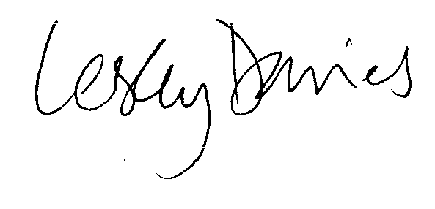
Lesley Davies
Director of Policy and Research

