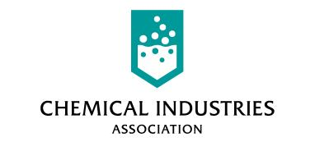
Kings Buildings
Smith Square
London SW1P 3JJ

Telephone: 020 7834 3399
Fax: 020 7834 4469

Direct phone: 020 79636718

Direct fax: 020 78348587

e-mail: SiddallR@cia.org.uk

www.cia.org.uk
28th May 2002
Ms Lisa Vango
Office of Gas and Electricity Markets
9 Millbank
London
SW1P 3GE

Dear Ms.Vango,

“Proposed merger of national grid group plc and lattice group plc to create national grid transco.”

I am writing in response to the above consultation of 16th May 2002. The chemical industry in the UK employs 239,000 highly-skilled people nationwide, and accounts for 2 per cent of Gross Domestic Product and 11 per cent of manufacturing industry’s gross value added. It invests £3 billion annually (plus £3.2 billion on R&D) and is our top manufacturing export earner, with an annual trade surplus of over £4 billion on a gross output of £48 billion.

The chemical industry is the largest user of electricity in the manufacturing sector, accounting for 20% of industrial demand, which is approximately 6% of total UK supply. The sector uses some 23000GWh annually, of which approximately 15000GWh is purchased from electricity supply companies at a cost greater than £400m. The chemical industry is also the largest user of natural gas in the manufacturing sector accounting for 33% of industrial usage of indigenous methane, which represents over 6% of total UK supply. The sector uses over 65,000GWh of natural gas annually, purchased at a cost over £550m.

Given the importance of the chemical sector to the UK economy, and that secure and competitive energy supplies are critical to its international competitiveness, CIA takes the possible effects of the proposed merger very seriously. It trusts that OFGEM and GEMA will consider the issues set out in the consultation paper carefully from the stand-point of end-users.

CIA cannot comment on detailed linkages between the monopolies, but chemical companies have highlighted three broad areas of concern in discussions about the merger:

- The beneficiaries of economies of scale: We believe there to be great scope for economies of scale through the proposed merger. Because NGC and Transco are already large-regulated-monopolies, we do not believe that this poses a general problem. However, CIA believes strongly that the Regulator must review and adjust price controls following such a merger. Price control regulation is underpinned by the principle that natural monopolies should be permitted to earn reasonable, but not excessive, return on their activities. If it transpires that the scope for economies of scale is large, then we believe a significant proportion of the additional future profits should be shared with end-users, who have no alternative choice regarding gas or electricity transportation. Moreover, we believe OFGEM should consider means of passing through benefits to end-users in this price control period, rather than permitting the new entity to earn increased rent over a 4 to 5 year period, before benefits flow through to end users.
- The potential for commercial conflicts of interest: the consultation paper alludes to the potential for conflicts of interest in the commercial operations of both NGC and Transco. CIA has concerns in two particular areas, where we believe there is potential for unforeseen and unwanted consequences:
  - Spot market prices: Our concern is that, in order to balance their networks, NGC and Transco both have significant roles as energy traders in addition to their normal business. In particular, Transco trades substantial volumes of energy on the OCM, which is operated by enMO, a subsidiary of NGC. Given that the wholesale gas market has undergone significant consolidation in recent years, is characterised by a small number of large players; and that spot market gas prices have shown substantial volatility in relation to events in the past, we urge OFGEM to consider very carefully the potential for behaviour, arising from the merger, that might lead to a less competitive wholesale market.
  - Opportunities for arbitrage: we note that electricity and gas are physically very different products. The UK electricity is a dynamic half hourly market, whereas gas trading is characterised by the gas day. We ask OFGEM to consider carefully the potential for the current incentives, which have been set-up under the separate price controls, to become perverse incentives upon National Grid Transco leading it to exploit of opportunities for arbitrage between energy markets.
- The focus of senior management: CIA believes that one reason for the merger is to create an entity more able to compete for non-regulated business abroad. While, in principle, we do not appose the company seeking new revenue streams, we are concerned about the potential for such aspirations, particularly during an initial period of enthusiasm, to consume senior management time, which ought to be spent on realising efficiency gains in the regulated business. We draw OFGEM’s attention to the potential for parallels with the water sector, where throughout the 1990’s, newly-privatised players pursued a raft of strategies aimed at developing large-turnover non-regulated businesses. Many of these floundered due to over-optimistic beliefs about ability to enter foreign markets and because the companies’ competencies, unsurprisingly, lay in their core businesses. Though some players were successful, many diverted large amounts of board-member effort into strategies that were later abandoned, or significantly curtailed. We strongly urge OFGEM to consider this aspect in advice to the relevant competition authorities and in its later thinking and consultation on regulatory aspects of the merger.

I trust this sets-out the principal concerns from the point of view of the chemical industry, and would be happy to discuss any of the above areas in greater detail.

Yours sincerely.

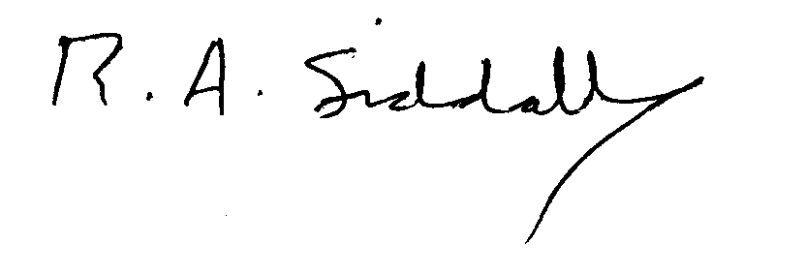

Robert A Siddall
Utilities Policy Manager.

